EE 5356 - DIGITAL IMAGE PROCESSING - PROJECT 5

NAME: PAVAI ARCHIMEDES

ST ID: 1001233996

Histogram Equalization and Specification

Steps:

1. Read ‘elaine.512.tiff’ image and obtain its histogram.

2. Perform global histogram equalization on the image and obtain its histogram.

3. Perform local histogram equalization on the image and obtain its histogram.

4. Perform direct histogram specification on the image where the desired histogram is a straight line from (0,0) to (1,1).

5. Repeat step 1 to 4 for ‘pout.tif’ image.

Submit the following:

1. Display the image and its histogram obtained in each step.

2. Compare the histogram modification techniques.

3. Give the matlab code.

MATLAB PROGRAM:

clc;

clear all;

close all;

% read the image of size 512x 512

Img1 = imread('C:\Users\PAVAI ARCHIMEDES\Desktop\elaine.512.tiff');

figure(1);

subplot(1,2,1);

imshow(uint8(Img1));% change from double to unsigned integer 8 bit

title('Original image');

subplot(1,2,2);

imhist(uint8(Img1));

title('His of ori img');

global_equalization = histeq(Img1);

figure(2);

subplot(1,2,1);

imshow(global_equalization);

title('global histogram equalization of img');

subplot(1,2,2);

imhist(uint8(global_equalization));

title('Histogram for abv img');

local_equalization = adapthisteq(Img1);

figure(3);

subplot(1,2,1);

imshow(local_equalization);

title('local histogram equ of img');

subplot(1,2,2);

imhist(uint8(local_equalization));

title('Histogram for abv img');

tempor = linspace(0,1,512);

direct_eq = histeq(Img1,tempor);

figure(4);

subplot(1,2,1);

imshow(direct_eq);

title('direct histogram equ of img');

subplot(1,2,2);

imhist(uint8(direct_eq));

title('Histogram for abv img');

Image2 = imread('C:\Users\PAVAI ARCHIMEDES\Desktop\pout.tif');

figure(5);

subplot(1,2,1);

imshow(uint8(Image2));

title('Ori img');

subplot(1,2,2);

imhist(uint8(Image2));

title('Histogram for ori img');

global_equalization2 = histeq(Image2);

figure(6);

subplot(1,2,1);

imshow(global_equalization2);

title('global histogram equ of img');

subplot(1,2,2);

imhist(uint8(global_equalization2));

title('Histogram for abv img');

local_equalization2 = adapthisteq(Image2);

figure(7);

subplot(1,2,1);

imshow(local_equalization2);

title('local histogram equ of img');

subplot(1,2,2);

imhist(uint8(local_equalization2));

title('Histogram for abv img');

tempor2 = linspace(0,1,240);

direct_equalization2 = histeq(Image2,tempor2);

figure(8);

subplot(1,2,1);

imshow(direct_equalization2);

title('direct histogram equ of img');

subplot(1,2,2);

imhist(uint8(direct_equalization2));

title('Histogram for abv img');

OUTPUT:

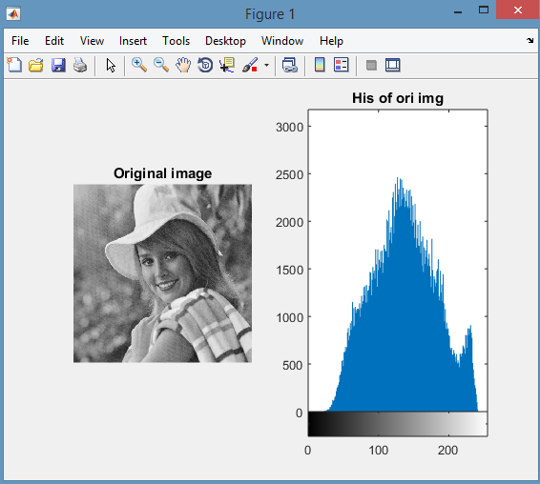

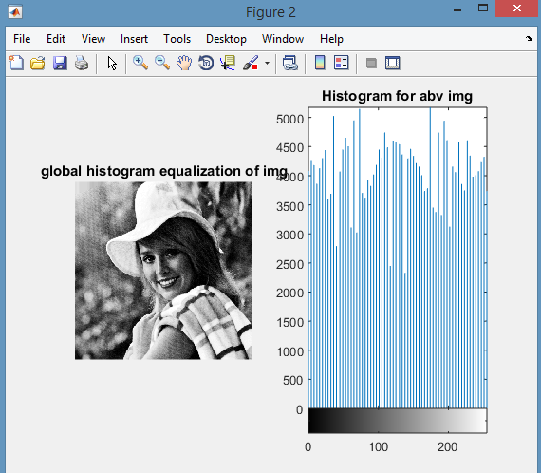

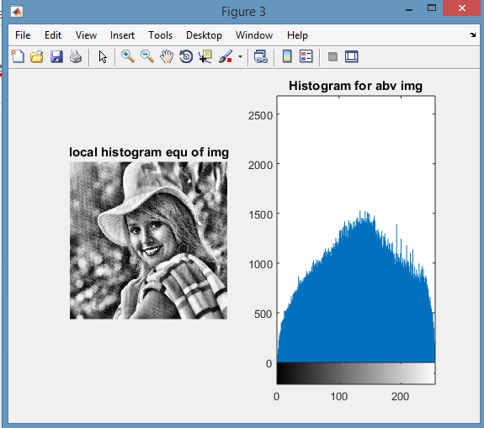

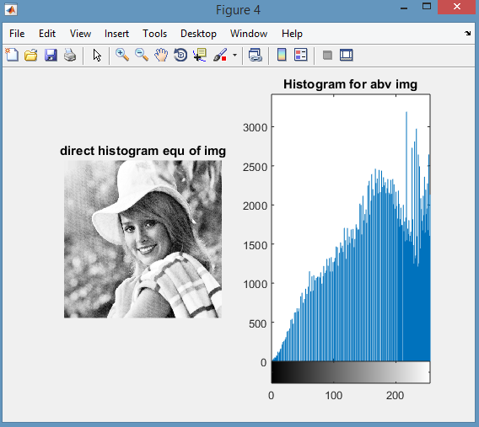

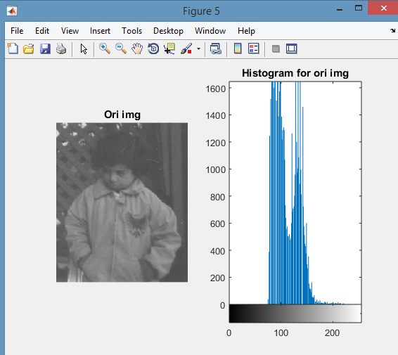

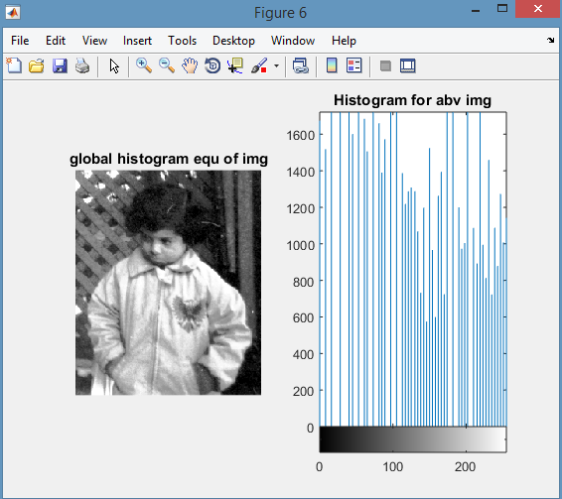

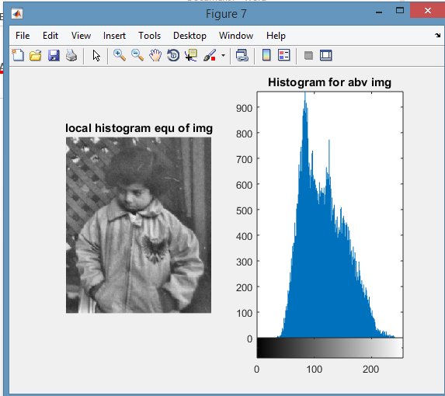

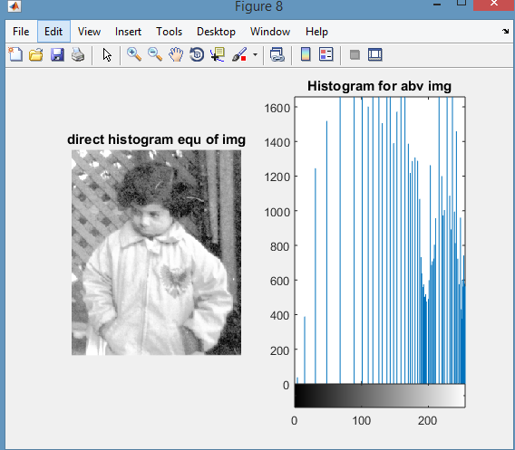

CONCLUSION:

* When few details of image is needed we can use direct histogram equalization.
* By using global histogram equalization we can bring out more details of image .
* The manipulation of window requires more calculation in local histogram globalization.